Mobile Devices Detection and View Switching

# Introduction

Today, we browse various web sites using iPhone, iPad, Android, Windows Phone 7 and so on. Since capabilities differ across devices, web developers sometimes need to detect browser capabilities when developing cross-platform mobile web applications. In some cases, it is best to implement this detection on server side and to deliver different sets of markup depending on the device.

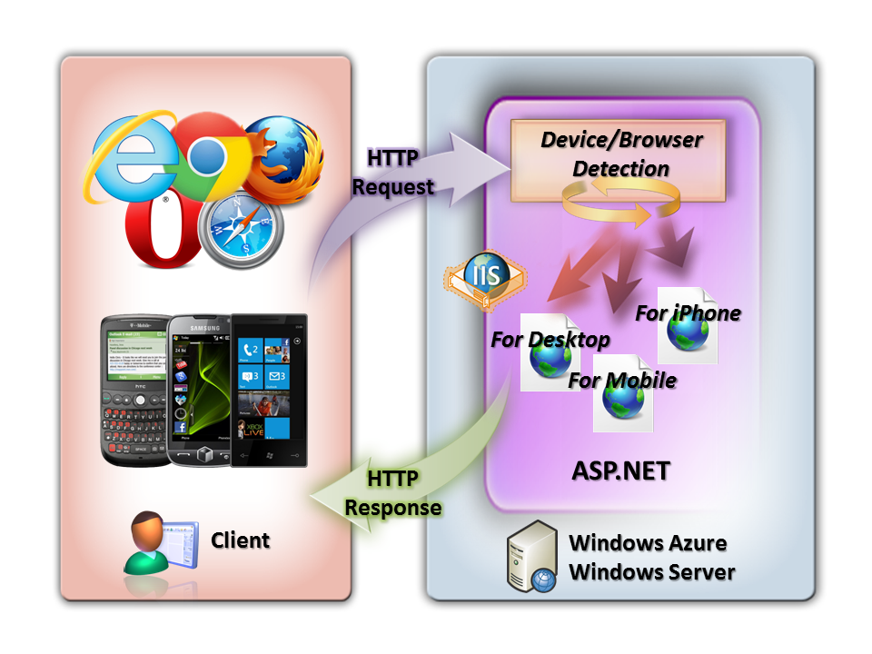

Requests from mobile devices and responses from web servers

This article demonstrates how to 'switch views' when a mobile device is detected. That is, how to deliver different content to a mobile device. In this article, we will use ASP.NET MVC 4 Developer Preview.

**Note:** If you want to know how to add mobile web pages to your web application built on ASP.NET Web Forms or ASP.NET MVC 3, please see below:

**How To: Add Mobile Pages to Your ASP.NET Web Forms / MVC Application**

http://www.asp.net/learn/whitepapers/add-mobile-pages-to-your-aspnet-web-forms-mvc-application

## System Requirements

Before you execute the sample code, the following must be installed:

* Windows 7, Windows Server 2003, Windows Server 2008, Windows Server 2008 R2, Windows Vista, Windows XP
* Visual Studio 2010 SP1 or Visual Web Developer 2010 SP1
* [ASP.NET MVC 4 Developer Preview for Visual Studio 2010](http://www.microsoft.com/download/en/details.aspx?displaylang=en&id=27419)
* [Windows Phone SDK 7.1 - Windows Phone Emulator](http://www.microsoft.com/download/en/details.aspx?displaylang=en&id=27570)
* NuGet version 1.5 or later

## Download Sample Code

You can download a sample code that is used in this article here:

<https://github.com/liike/aspnet-mvc-mobile-samples>

## Sample Application on Windows Azure

Additionally, you can try the sample application on Windows Azure as follows:

<http://akirainpp.cloudapp.net/>

## Select a view depending on the browser with ASP.NET MVC 4

### Display Modes in ASP.NET MVC 4 Developer Preview

The **Display Modes** feature of ASP.NET MVC 4 allows a web application select views depending on the browser that is making the request. With this feature, the mobile devices are detected using the standard Browser.IsMobileDevice call from HttpBrowserCapabilities properties of ASP.NET.

For example, if a desktop browser requests the index page (and Browser.IsMobileDevice == false), the application would likely use the Views\Home\Index.cshtml as the view. However, if a mobile browser requests the same index page (making Browser.IsMobileDevice == true), then then application would return the Views\Home\Index.Mobile.cshtml instead.

Layouts and partials can also be overridden based on Browser.IsMobileDevice value. For example:

* If your Views\Shared folder contains both the _Layout.cshtml and _Layout.Mobile.cshtml templates, then by default the application will use _Layout.Mobile.cshtml during requests it believes are from mobile browsers and _Layout.cshtml during other requests.
* If a folder contains both _MyPartial.cshtml and _MyPartial.Mobile.cshtml, then the instruction @Html.Partial("_MyPartial") will actually render _MyPartial.Mobile.cshtml for requests from mobile browsers, and _MyPartial.cshtml during other requests.

If you want to create more specific views, layouts, or partial views for other devices, you can register a new DefaultDisplayMode instance and specify which name to search for when a request satisfies particular conditions. For example, you could add the following code to the Application_Start method in the Global.asax file to register the string "iPhone" as a display mode that applies when the Apple iPhone browser makes a request:

DisplayModes.Modes.Insert(0, new DefaultDisplayMode("iPhone")

{

ContextCondition = (context => context.Request.UserAgent.IndexOf("iPhone", StringComparison.OrdinalIgnoreCase) >= 0)

});

After this code runs, when an Apple iPhone browser makes a request, your application will use the Views\Shared\_Layout.iPhone.cshtml layout (that is, if ones exists).

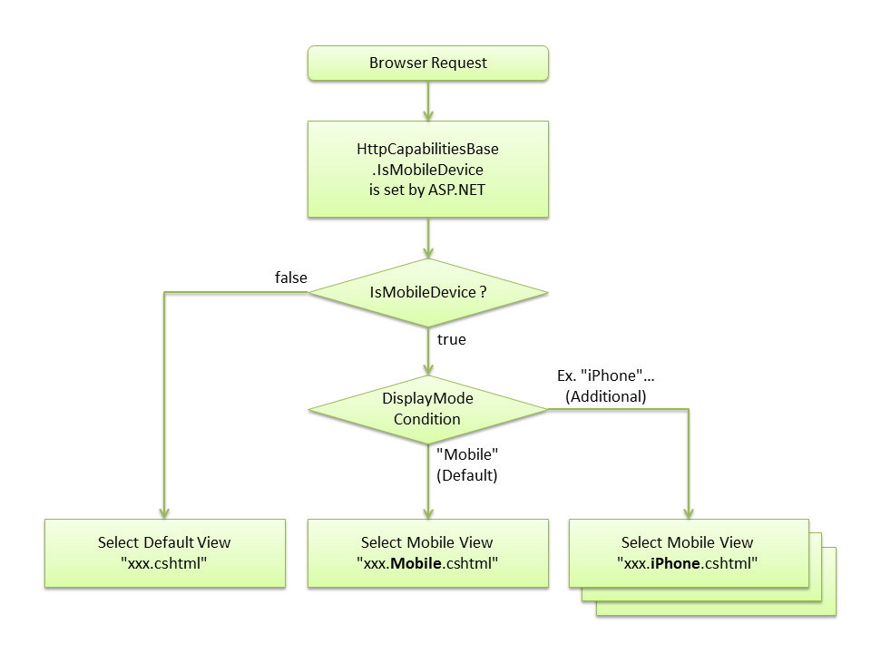

View Switching in ASP.NET MVC 4 Developer Preview

## jQuery Mobile with ASP.NET MVC 4

[jQuery Mobile](http://jquerymobile.com/) is a well-known open source library for building touch-optimized mobile web application. jQuery Mobile is included in Mobile Application project template of ASP.NET MVC 4 as default. However, if you want to use jQuery Mobile with an ASP.NET MVC 4 project template, you can download and install it from the Visual Studio Package Manager Console (NuGet) using the following command:

PM> Install-Package jQuery.Mobile.MVC

This package installs jQuery Mobile and some helper files, including the following:

* Views/Shared/_Layout.Mobile.cshtml, which is a jQuery Mobile-based layout.
* A view-switcher component, which consists of the Views/Shared/_ViewSwitcher.cshtml partial view and the ViewSwitcherController.cs controller.

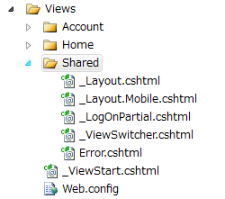

shared views

After you install the package, run your application using a mobile browser (or equivalent, like the [Firefox User Agent Switcher add-on](https://addons.mozilla.org/en-US/firefox/addon/user-agent-switcher/)). You'll see that your pages look quite different, because jQuery Mobile handles layout and styling. To take advantage of this, you can do the following:

* Create mobile-specific view overrides as described under **Display Modes** earlier (for example, create Views\Home\Index.Mobile.cshtml to override Views\Home\Index.cshtml for mobile browsers).

**Note:** Read the [jQuery Mobile documentation](http://jquerymobile.com/) to learn more about how to add touch-optimized UI elements in mobile views.

A common convention for mobile-optimized web pages is to add a link whose text is something like â€œGo to Desktop Siteâ€ or â€œFull site modeâ€ that lets users switch to a desktop version of the page. The jQuery.Mobile.MVC package includes a sample view-switcher component for this purpose. Sample view-switcher component codes are as follows:

// from ViewSwitcherController.cs

using System.Web.Mvc;

using System.Web.WebPages;

namespace Mvc_ViewSwitcher.Controllers

{

public class ViewSwitcherController : Controller

{

public RedirectResult SwitchView(bool mobile, string returnUrl)

{

if (Request.Browser.IsMobileDevice == mobile)

HttpContext.ClearOverriddenBrowser();

else

HttpContext.SetOverriddenBrowser(mobile ?

BrowserOverride.Mobile : BrowserOverride.Desktop);

return Redirect(returnUrl);

}

}

}

// _ViewSwitcher.cshtml

@if (Request.Browser.IsMobileDevice && Request.HttpMethod == "GET")

{

<div class="view-switcher ui-bar-a">

@if (ViewContext.HttpContext.GetOverriddenBrowser().IsMobileDevice)

{

@Html.ActionLink("Go to Desktop Site", "SwitchView", "ViewSwitcher", new { mobile = false, returnUrl = Request.Url.PathAndQuery }, new { rel = "external" })

}

else

{

@Html.ActionLink("Go to Mobile Site", "SwitchView", "ViewSwitcher", new { mobile = true, returnUrl = Request.Url.PathAndQuery }, new { rel = "external" })

}

</div>

}

It's used in the default Views\Shared\_Layout.Mobile.cshtml view, and it looks like this when the page is rendered:

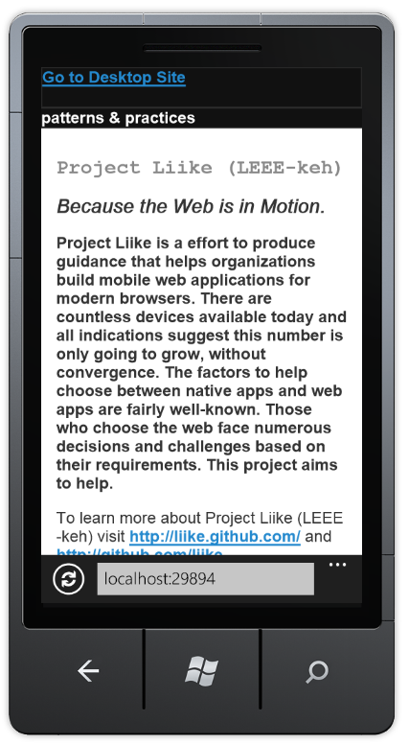

rendered on mobile

If you click the link, it will switch to the desktop version of the same page.

In jQuery.Mobile.MVC package, the desktop layout (_Layout.cshtml) will not include a view switcher by default, so you won't have a way to get to mobile mode. To enable this, add the following reference to _ViewSwitcher to your desktop layout, just inside the <body> element:

<body>

<header>

@Html.Partial("_ViewSwitcher")

...

After adding this, the desktop version of the page in mobile browser will include the mobile mode link in it.

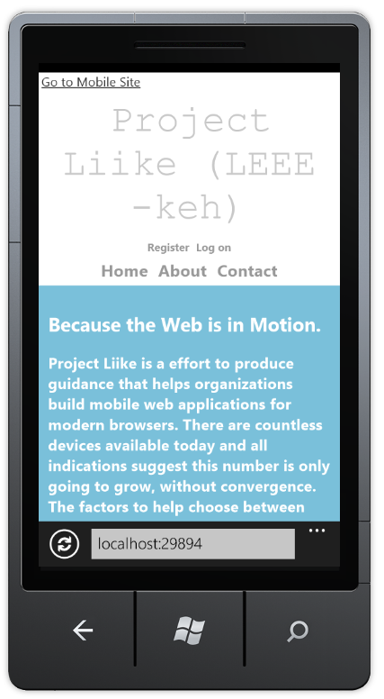

displaying the switching link

However, if you browse the desktop version of the page using desktop browser, the mobile mode link will not appear in the page.

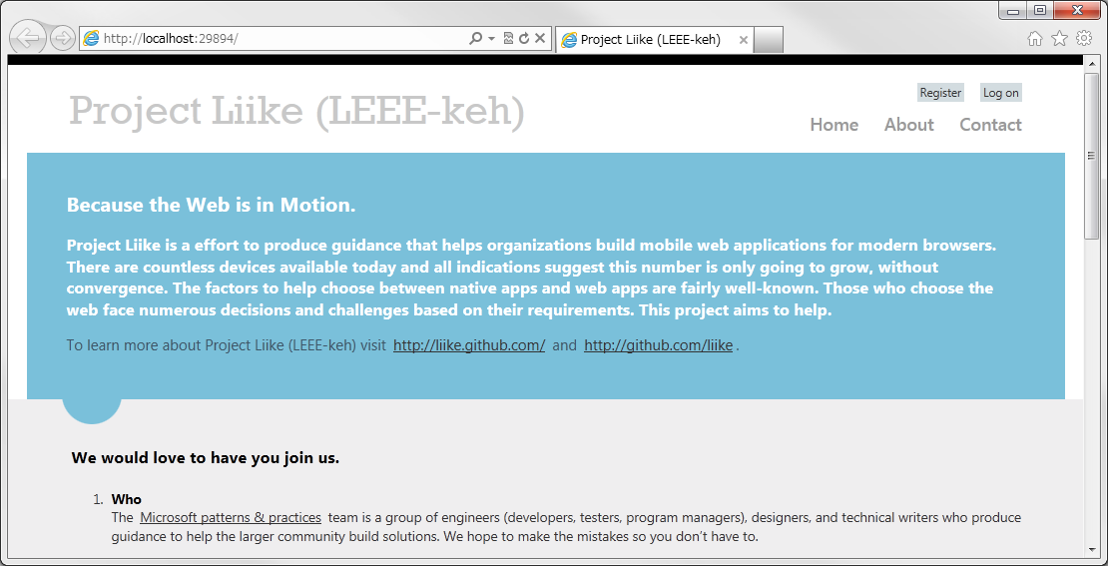

rendered in a desktop browser

The view switcher uses a new feature of ASP.NET MVC 4 called **Browser Overriding**. This feature lets your application treat requests as if they were coming from a different browser (user agent) than the one they're actually from. The following table lists the methods that Browser Overriding provides.

|  |  |
| --- | --- |
| HttpContext.SetOverriddenBrowser(userAgentString) | Overrides the request's actual user agent value using the specified user agent. |
| HttpContext.GetOverriddenUserAgent() | Returns the request's user agent override value or the actual user agent string if no override has been specified. |
| HttpContext.GetOverriddenBrowser() | Returns an HttpBrowserCapabilitiesBase instance that corresponds to the user agent currently set for the request (actual or overridden). You can use this value to get properties such as IsMobileDevice. |
| HttpContext.ClearOverriddenBrowser() | Removes any overridden user agent for the current request. |

Browser Overriding is a core feature of ASP.NET MVC 4 and is available even if you don't install the jQuery.Mobile.MVC package. However, it affects only view, layout, and partial-view selection â€” it does not affect any other ASP.NET feature that depends on the Request.Browser object.

By default, the user-agent override is stored using a cookie. If you want to store the override elsewhere (for example, in a database), you can replace the default provider (BrowserOverrideStores.Current).

## Select views depending on the browser with ASP.NET MVC 3

If you use ASP.NET MVC 3, you can use the MobileViewEngines package. To install it from the Visual Studio Package Manager Console (NuGet), type the following command:

PM> Install-Package MobileViewEngines

Unfortunately you cannot use the Display Modes feature with ASP.NET MVC 3. Instead, you have to write some additional code. The following is an example of what you can add your ASP.NET MVC 3 project based on MobileViewEngines.

1. After the MobileViewEngines installation, add the following codes to MobileCapableRazorViewEngine.cs (or MobileCapableRazorViewEngine.vb):

private ViewEngineResult NewFindView(ControllerContext controllerContext, string viewName, string masterName, bool useCache, bool isPartialView)

{

if (!ContextCondition(controllerContext.HttpContext))

{

return new ViewEngineResult(new string[] { });

}

HttpCookie viewSwitcher = controllerContext.RequestContext.HttpContext.Request.Cookies["ViewSwitcher"];

if (viewSwitcher != null && viewSwitcher["Mobile"] != null)

{

if (String.Equals(viewSwitcher["Mobile"], "false"))

return new ViewEngineResult(new string[] { });

}

...

1. Add the following Controller code as ViewSwitcherController.cs to your project:

using System.Web.Mvc;

using System.Web.WebPages;

namespace Mvc_ViewSwitcher.Controllers

{

public class ViewSwitcherController : Controller

{

public RedirectResult SwitchView(bool mobile, string returnUrl)

{

Response.Cookies["ViewSwitcher"]["Mobile"] = (mobile ? "true" : "false");

return Redirect(returnUrl);

}

}

}

1. Add the following View code as _ViewSwitcher.cshtml to your project:

@if (Request.Browser.IsMobileDevice && Request.HttpMethod == "GET")

{

<div class="view-switcher ui-bar-a">

@{

bool isMobileMode = Request.Browser.IsMobileDevice;

if (Request.Cookies["ViewSwitcher"] != null && Request.Cookies["ViewSwitcher"]["Mobile"] != null)

{

isMobileMode = String.Equals(Request.Cookies["ViewSwitcher"]["Mobile"], "true");

}

if (isMobileMode)

{

@Html.ActionLink("Go to Desktop Site", "SwitchView", "ViewSwitcher", new { mobile = false, returnUrl = Request.Url.PathAndQuery }, new { rel = "external" })

}

else

{

@Html.ActionLink("Go to Mobile Site", "SwitchView", "ViewSwitcher", new { mobile = true, returnUrl = Request.Url.PathAndQuery }, new { rel = "external" })

}

}

</div>

}

1. Unfortunately, you have to prepare not only _Layout.Mobile.cshtml, but also mobile content view (such as Index.Mobile.cshtml), and add the following line to the mobile content view:

@{

ViewBag.Title = "Project Liike (LEEE-keh)";

Layout = "~/Views/Shared/_Layout.Mobile.cshtml";

}

** Note: You may need to consider other solution later **

1. Finally, add the following reference to _ViewSwitcher to your layout view:

@Html.Partial("_ViewSwitcher")

Following figure is a sample ASP.NET MVC 3 project based on MobileViewEngines:

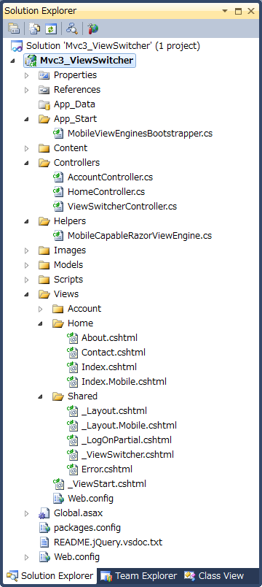

a project based on MobileViewEngines

For more details, you can download a sample code based on ASP.NET MVC 3 as follows: <https://github.com/liike/aspnet-mvc-mobile-samples/tree/master/Mvc3>

In this sample, HTTP Cookie is used instead of the Display Modes feature implemented in ASP.NET MVC 4.

## Detect mobile devices and browser capabilities

In Display Modes of ASP.NET MVC 4, the mobile devices detection is using the standard Browser.IsMobileDevice call from HttpBrowserCapabilities Properties of ASP.NET.

**HttpBrowserCapabilities Properties of ASP.NET:** <http://msdn.microsoft.com/en-us/library/system.web.httpbrowsercapabilities_properties.aspx>

If you want to implement more specific detection, you can use a browser database like 51Degrees.mobi and WURFL Official API (also on CodePlex and NuGet).

### 51Degrees.mobi

51Degrees.mobi: <http://51degrees.codeplex.com/>

Detect mobile devices, get very accurate handset properties and redirect to web pages designed for mobile devices, all with a simple configuration and without any external dependencies on a Cloud Service. Request.Browser properties will be populated with data from the WURFL open source project so you can still use the default .NET properties but be assured that they're accurate.

PM> Install-Package 51Degrees.mobi

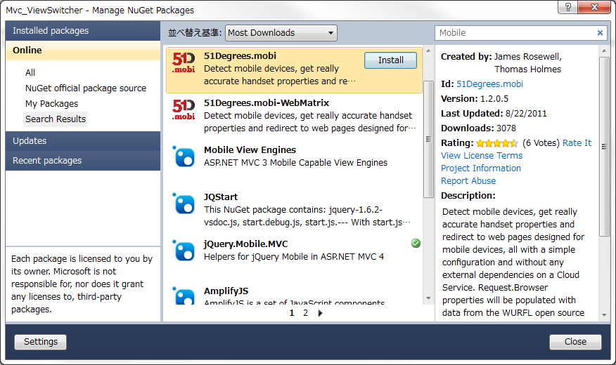

installing 51Degree

### WURFL Official API

WURFL Official API: <http://wurfl.sourceforge.net/>

WURFL is a data repository containing the description of thousands of mobile devices. You use the library to query browser and device capabilities from the user-agent string. Delivering a mobile application to multiple devices typically requires adjusting of HTML/XHTML mark-up, CSS and JavaScript. Similarly, no single combination of audio/video codecs and containers will work on all devices (not to mention frame-rates and bit-rates). For all these reasons, a Device Description Repository is required that can be queried to know whether a given device supports a given feature. An open-source database, WURFL is de-facto standard DDR in the industry. This package delivers the official WURFL ASP.NET API.

PM> Install-Package WURFL_Official_API

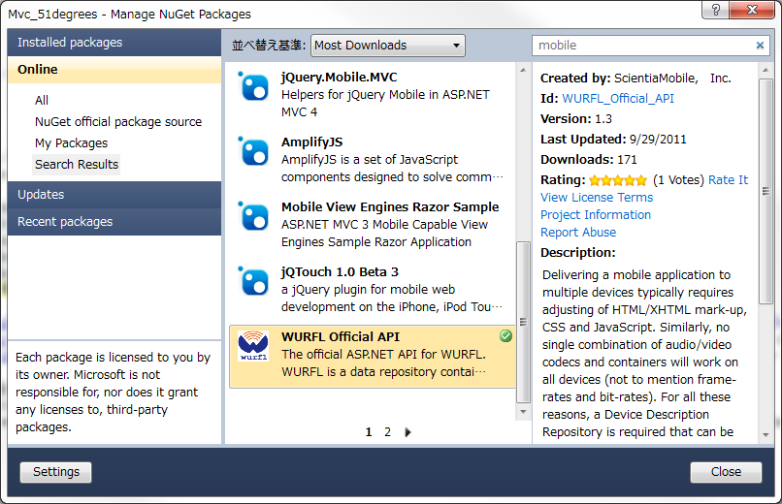

installing WURFL

### Accurate browser capabilities

Depending on your application, it may also be important to detect browser capabilities such as screen size, pointing method and so on.

The following code returns the mobile device browser capabilities. These calls will return more accurate data than HttpBrowserCapabilities properties of ASP.NET if you use the 51degrees.mobi and WURFL Official API.

var Manufacturer = Request.Browser.MobileDeviceManufacturer;

var DeviceModel = Request.Browser.MobileDeviceModel;

var ScreenWidth = Request.Browser.ScreenPixelsWidth;

var ScreenHeight = Request.Browser.ScreenPixelsHeight;

var TabletDevice = Request.Browser["is_tablet"];

var PointingMethod = Request.Browser["pointing_method"];

The following figure is a sample of mobile web application that is using 51degrees.mobi. You can detect screen size, pointing method and so on easily.

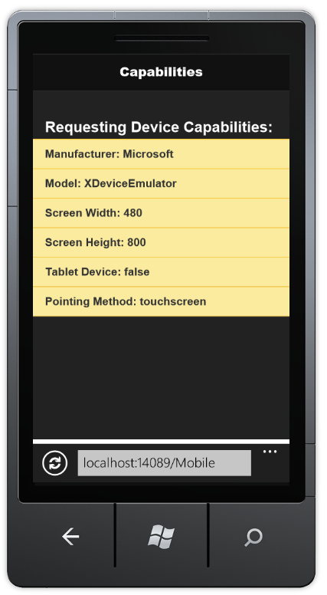

app using 51degrees

## Summary

The demand and importance for modern mobile web development is rapidly increasing recently. Because we have to build web applications that we can use anytime, anywhere and on any device, understanding when and how to use techniques such as the ones outlined in this article are an important component of cross-platform mobile web development.

Akira Inoue - November 2nd, 2011

## Bibliography

**ASP.NET MVC 4 Developer Preview Release Note** (Display Modes and jQuery Mobile, the View Switcher, and Browser Overriding) <http://www.asp.net/learn/whitepapers/mvc4-release-notes#_Toc303253810>

**New Mobile View Engines for ASP.NET MVC 3, spec-compatible with ASP.NET MVC 4** <http://www.hanselman.com/blog/NuGetPackageOfTheWeek10NewMobileViewEnginesForASPNETMVC3SpeccompatibleWithASPNETMVC4.aspx>

**HttpBrowserCapabilities Properties of ASP.NET** <http://msdn.microsoft.com/en-us/library/system.web.httpbrowsercapabilities_properties.aspx>

**How To: Add Mobile Pages to Your ASP.NET Web Forms / MVC Application** <http://www.asp.net/learn/whitepapers/add-mobile-pages-to-your-aspnet-web-forms-mvc-application>

**51Degrees** <http://51degrees.mobi> <http://51degrees.codeplex.com/> <http://nuget.org/List/Packages/51Degrees.mobi>

**WURFL Official API** <http://www.scientiamobile.com/site/index> <http://nuget.org/List/Packages/WURFL_Official_API>